GANG CUTTING RIBS FROM TEMPLATE
JIM TAYLOR
Photo’s by Doc Ferguson

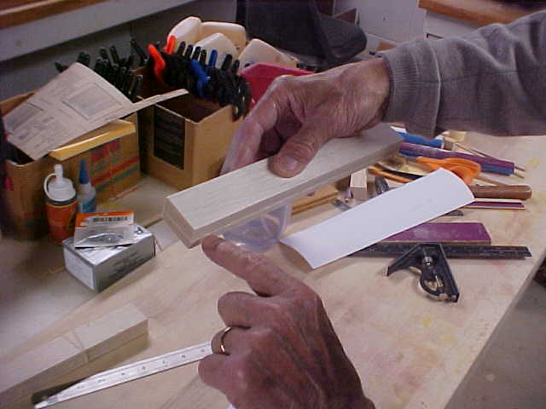

In preparing the balsa it is important that the length and width are close as possible while leaving a little space around the edges for final trimming.

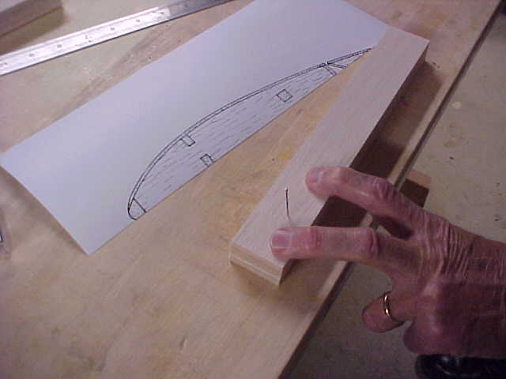
Use a sturdy straight pin to insert into our ten pieces of balsa in order to keep them together during cutting.

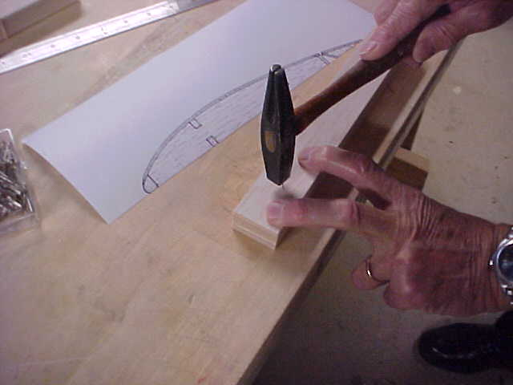

The pin is driven through all ten pieces of balsa flush with the surface of the top sheet.

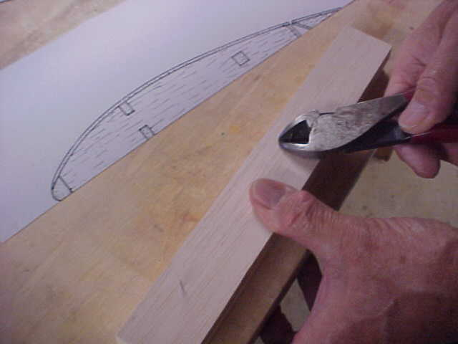

A side cutter makes short work of trimming the pins as close as possible to the wood. Any excess causes difficulty when swing the stack. Be sure not to place pins where the saw blade must make a cut.

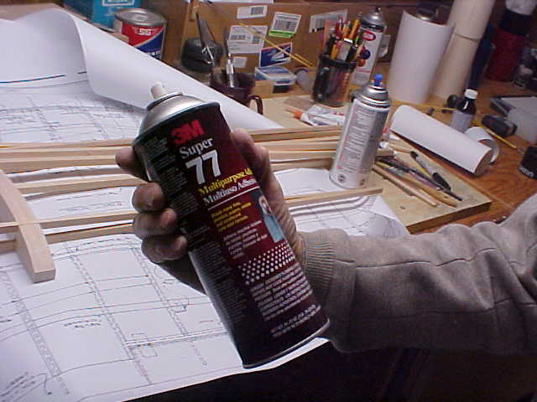

3M has a wonderful product Super 77. Almost any mounting adhesive will work. I like the Super 77 as it dries quickly and tacks well to the paper template that we will affix to our balsa.

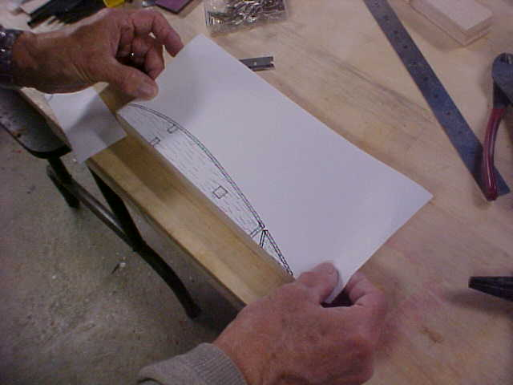
The back of the template, a photo copy of the wing section, has been sprayed and now it needs to be aligned to our balsa. The base of the balsa has been sanded even. We position the template to the base of our balsa and begin smoothing down.

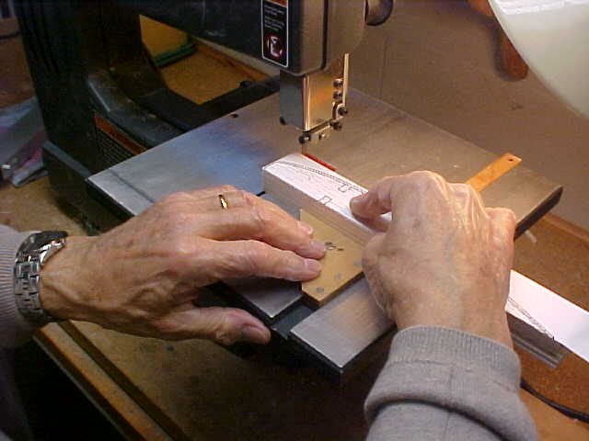

I use a square with my band saw to cut the front of the rib to 90 degrees or what ever is required. The band saw cut straight unlike a scroll saw. Use a metal cutting blade, or a fine tooth blade, as it has more teeth and a smother cut is made in the soft balsa.

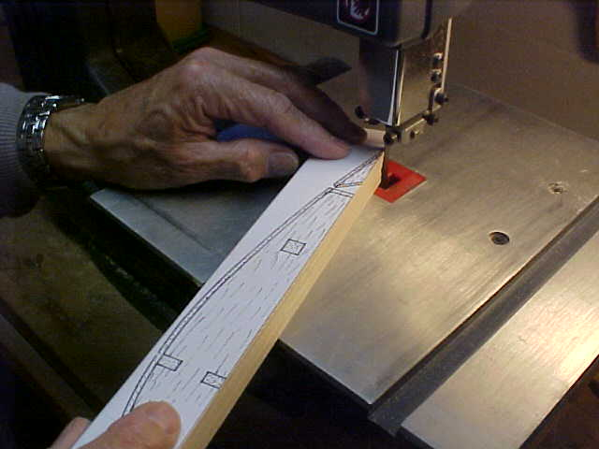

This is where you want to take your time. A steady hand and feed the work slowly cutting as close to the black line as possible. You can see, I think, that this method works only for wings that are constant chord. Otherwise, each rib must be cut separately since each successive rib may be smaller than the previous one.

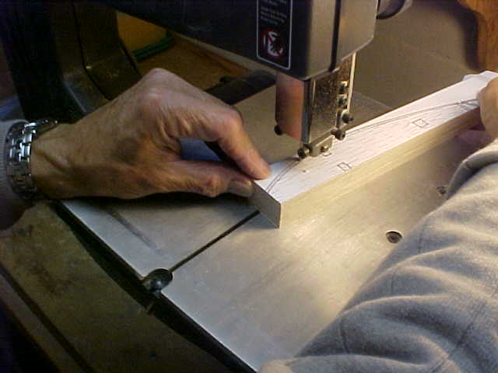

Again I cannot emphasis to really take your time. No sense in ruining ten pieces of balsa and have to start over. We are trying to save time. So take time. Cut the outline just a little bigger than the template and finish to final size with a sandpaper block.

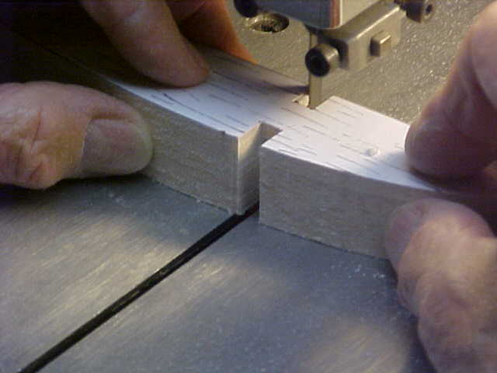
For our spars I make careful multiple cuts to make a clean channel for our spars Cut the sides first, then make multiple cuts to the proper depth and remove the excess in that manner.

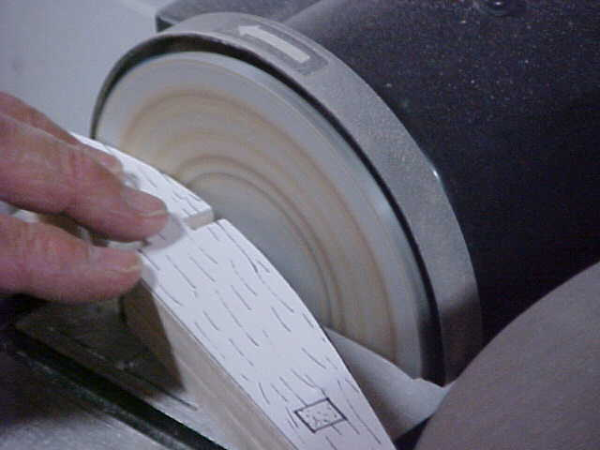
This is a tool that I highly recommend. A sanding disk. If any of those black lines are still there this is where you can get rid of them fast. Again take your time. These disk are really fast at removing material.

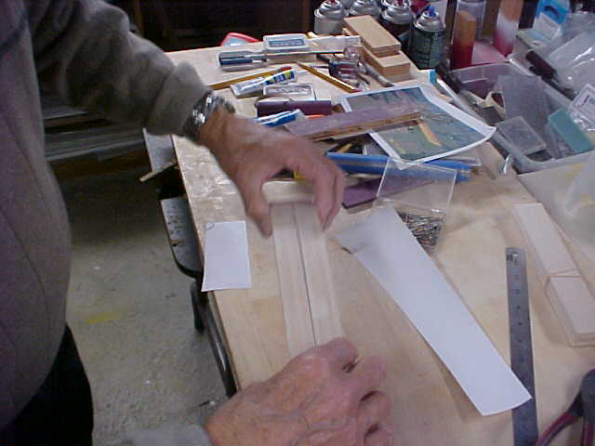

I had already cut out ten other ribs. Now we place them together and check of differences in ht. By using a sharps pen we can trace along the high end and take those ten to the belt or disk sander to make everything even.

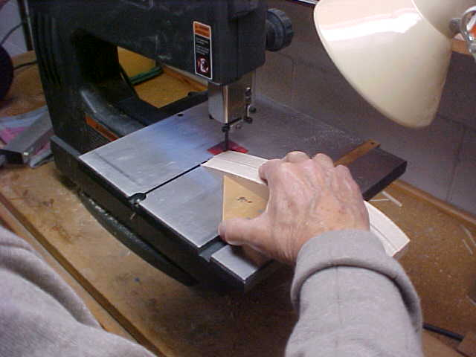

We can trim up our tail pieces of ribs on the band saw using the square once again.

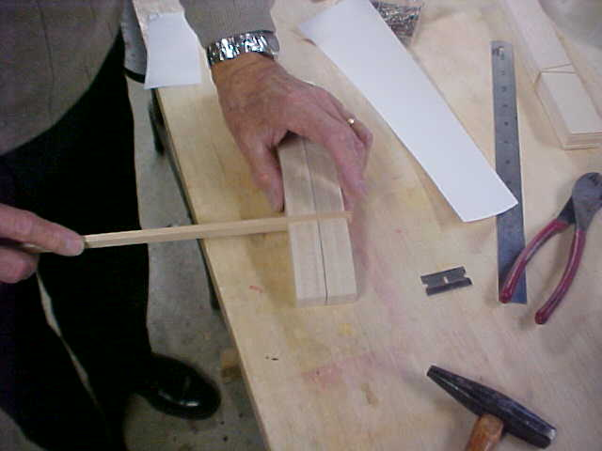

This is where we test fit our spar to the top and bottom of our prepared ribs. If necessary use a special sanding tool using square hardwood with sandpaper glued to one sideto expand or deepen the slot.

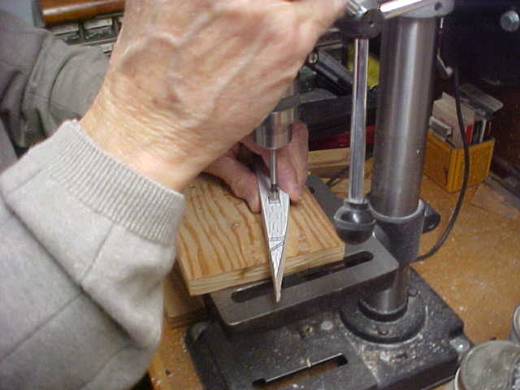
These particular ribs have a square hole that needs to be made through all ten ribs.
Choose a Forstner bit and center it in the intended hole. Chose a bit that is close to the sides to remove as much material as possible. Making a round hold into a square hole. I prefer this to using a scroll saw. Scroll saws want to wander from side to side and you cannot get a clean square cut. By removing as much material as possible another tool that you can make yourself makes a better square hole.

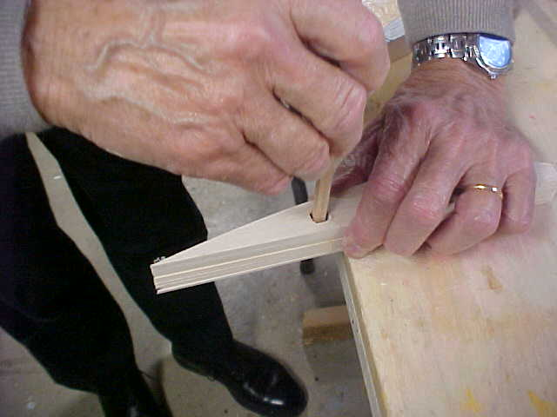

Sandpaper glued to two sides of a square hardwood stick makes a good hole-sizing tool.

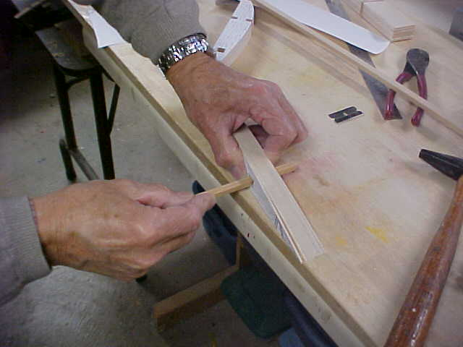

Use a small square piece of balsa and glue sand paper to two sides. Work the tool top to bottom and side to side to get a nice square hole. Don’t over do it as you are going to test fit the main center spar that runs through all the ribs.

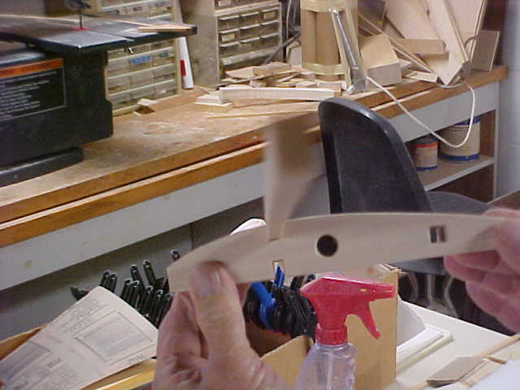

Spar is test fitted through all ten ribs top bottom. Note round hole which will be used for the wiring of the servo. Note the square hole. That was also test fitted with the spar for proper fit.

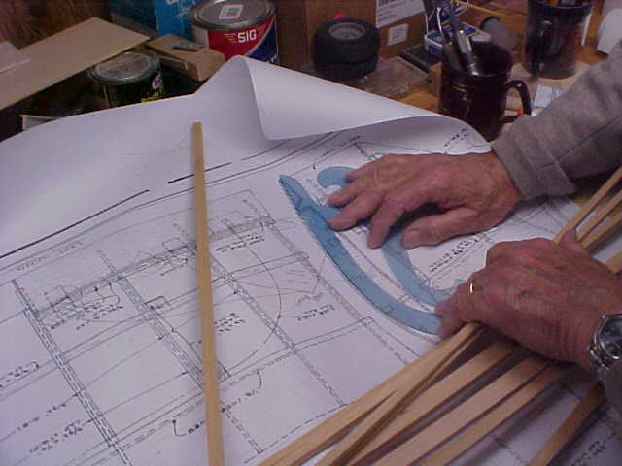

Using the French square. Use of the French square is more time consuming than duplicating your plan. However if you want to make permanent templates from plywood the French square duplicates the original rib very close. This can be done by pinning down the plans with a piece of vellum tracing paper on top. Use the French curve and very carefully trace the outline of the rib and a straight edge to draw the spar shape and locations. This tracing becomes the template for gang-sawing a batch of similar ribs.

That method is a different story which will be covered later.

